TechNet Australia AGM 2019
1:30pm, Friday 6 December 2019
KE1.207, Deakin University - Waurn Ponds Campus, Geelong, Victoria

Present: Mark Hayne (Chair), John Naumann, Jennie Nelson, Tim Clark, David Gleadon, Jane Hosking, Vanessa Glenn, Karen Teague, Wendy Brockhouse

Apologies: No apologies were recorded.

- Formalising TechNet Australia’s legal structure

Mark Hayne gave a summary of investigation into legal structures that may be suitable for TechNet Australia. Viable options are unincorporated association, incorporated association and company limited by guarantee. Incorporation is less onerous or expensive to maintain than company, but more formal than unincorporated association.

Matters to address include:
- Which state or territory to incorporate in (e.g. HESTA operates nationally but is incorporated in ACT)
- Future funding model. This could be like South Australian universities annually contributing funds to TechNet SA; surplus funds from conferences; individual membership fees.
- Membership classes. There was broad discussion on different systems such as individual memberships or university memberships (every tech in a member uni is automatically a TechNet Australia member – control and inclusivity were discussed in this context)
- Voting (financial) and non-voting (non-financial) membership classes
- Setting membership fees (e.g. HESTA is $20 per person per year)
- Legal definition of Treasurer and Secretary

- Future meetings
There was agreement that regular meetings via online teleconference in 2020 could help to progress TNA’s activities. This will be actioned.

- Other matters
Attendees discussed:
- TNA seeking a Whova app licence for future national conferences and for TechNet Lites
- Raising the profile of NEATTS
- Supporting Monash to raise the profile of the national conference in 2020

Signed by the Chair:

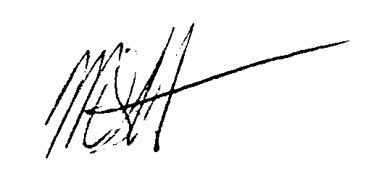

Mark Hayne

